Addendum:

The Story of Oak Grove School, District 20
Lincoln Township, Neosho County, Kansas

The story of the Oak Grove School is more than just the story of a one-room country schoolhouse. It is the story of a movement in history. It is the story of the Osage Indians who once made southeastern Kansas their home. It is the story of the post-Civil War settlers who plowed the prairie and converted it into a farmable living. It is the story of the railroads that brought modern transportation and industrialization to the American frontier. It is the story of the farm children who were educated in these rural one-room schools and who later became the heart and soul of America’s “greatest generation”.
Oak Grove was in the center of this movement in southeastern Kansas. Few such rural historical structures like it remain, particularly in their original geographic location. The Ingalls family cabin near Independence is gone. The notorious Bender “inn” near Cherryvale has disappeared. The once-bustling boom towns of Ladore and Jacksonville have vanished. And the once-competing Neosho county seats of St. Paul and Erie are only a shadow of their former selves. But one solitary country school remains. It has survived nearly 140 years of human wear and tear, the ravages of thunderstorms, prairie fires, floods, and the incessant onslaught of nature’s pests and insects. After all this, it still stands. And it is original – not a replica. It is there – on the prairie – an iconic symbol of the era that created it – and right where the early settlers of nineteenth-century Kansas built it.
In short, the Oak Grove School is a surviving witness to the history of rural Kansas and a testament to the sacrifice and dedication of our forbearers, whose efforts to carve out a living on a wild southeastern Kansas frontier developed the region into a land of prosperity and opportunity that too few today fully appreciate.
Date of Founding and Geographical Setting of the Oak Grove School
The original Oak Grove School, District 20, was established about 1868 in the southeast quarter of Section 25 of Lincoln Township, Neosho County, Kansas. The school was later moved in 1877 about 3/4 miles southwest to the northern boundary of the middle section line of Section 36 of Lincoln Township.
No detailed maps of Neosho County or Lincoln Township exist from this period of time (1868-1877). The earliest map that shows any detail of Neosho County and its townships is a land plat map from “The Standard Atlas of Neosho County, KS”, published in the year 1906. A copy of this map with an enlarged inset of Lincoln Township is shown below (Figure 1), noting the locations of the Oak Grove School in 1868 and 1877, and the approximate distance of these sites from the town of St. Paul, Kansas (formerly Osage Mission, Kansas in the years 1868-1877).
As can be seen on the 1906 map, the Oak Grove School sites were located about 7-8 miles due south of St. Paul (Osage Mission), about 1 to 1-1/2 miles west of the Neosho River, about 1 mile north of the county line boundary between Neosho and Labette counties, and about 8 miles due east of “Ladore Station” (on the MK&T (Katy) railroad line). This geographical setting is key to understanding the historical significance of this unique one-room school.
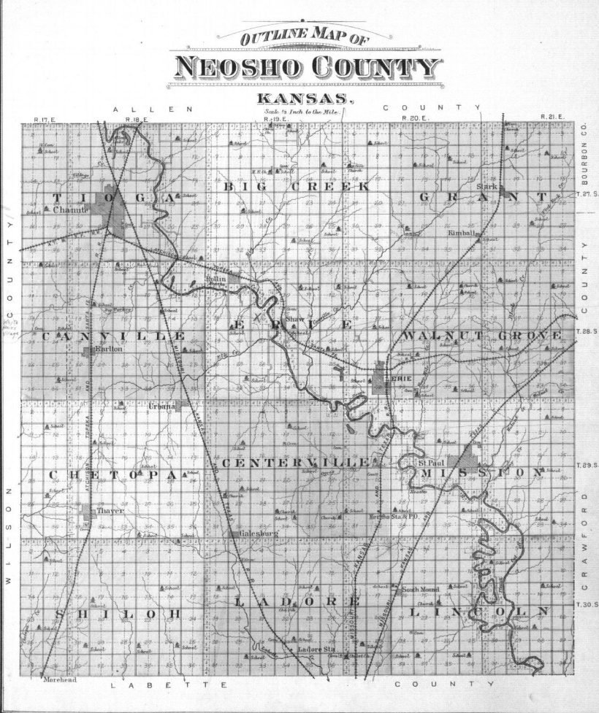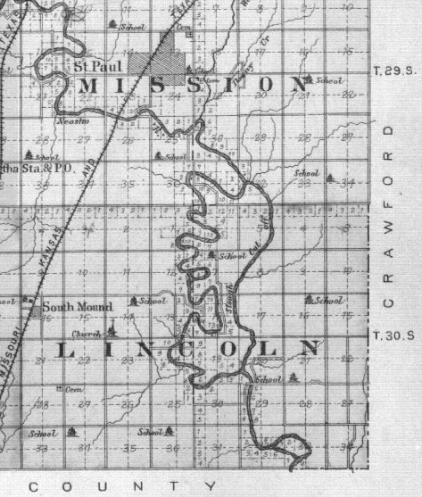
7-1/2 miles
Oak Grove School Site
1877 to present
Oak Grove School Site
1868 to 1876
Figure 1: Land Plat Map from the Standard Atlas of Neosho County, KS
1906

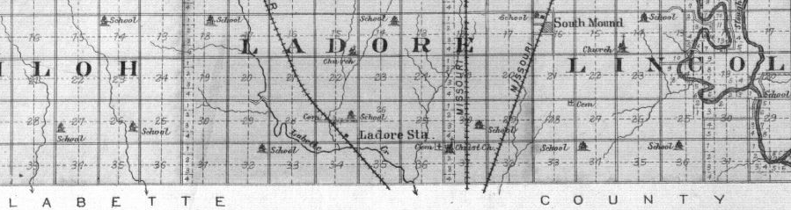
About 8 miles

Oak Grove, the Osage Trail, and Trotter’s Ford
The Osage Indians occupied southeastern Kansas from the early 1800’s, and their primary center of living was founded along the banks and lowlands of the Neosho River. Along its courses, the Osage hunted and foraged, and established villages and settlements. In the absence of bridges, they found the most convenient places to ford the river, and in so doing established the routes of travel that would systemically become known as the “Great Osage Trail". One artery of that trail crossed the Neosho at a fordable bend in the river about seven miles south-southeast of modern-day St. Paul, about one and a half miles east of the future site of the Oak Grove School. Early settlers referred to this river crossing as “Trotter’s Ford”. (History of Neosho County, Vol. I, by W.W. Graves, p. 296)
Prior to the Civil War Trotter’s Ford was used by the Osage as a primary river crossing route, and in the vicinity of this convenient crossing the Osage established one of their more prominent villages. John C. McCoy, one of the original surveyors of the Kansas Territory, recorded in a letter in 1885 that while surveying southeastern Kansas between the years of 1831 and 1838, he and another surveyor located the village of the Osage Indian Chief “White Hair” on the Neosho River “about seven miles below the site of what would later become Osage Mission (now St. Paul)” (Letter from John C. McCoy to Franklin G. Adams, dated February 9, 1885, Chouteau, Kansas, Kansas State Historical Society).
In January 1847 Larkin McGee established a trading post near Chetopa. He would also later record: “I found five white or partly white families there when I arrived. White Hair was the principal of the Osages and lived on the Neosho River six miles south of Osage Mission and down the river. This was the largest town in the Osage nation at that time.” (Letter dated December 1, 1891, Annals of Osage Mission, W.W. Graves, 1987, p.29)
Two attached maps from “A History of the Osage People” (Louis F. Burns, 2004, pp.57, 76) further support these claims. The first of these two maps (Figure 2: “Osage Villages and Camps in Kansas”) shows various villages along the Neosho River, but notably one of those villages is shown just south of Osage Mission on the west side of the river, close to a point where two branches of the Neosho River join together. This point in the river (known locally as the south end of an “island” formed by two branches of the Neosho) is located just a short distance upstream of Trotter’s Ford. So close in fact was Trotter’s Ford to the south end of this “island”, that in December 1871, a post office was established near Trotter’s Ford and was referred to as the “Island Post Office” (Annals of Osage Mission, W.W. Graves, 1987, p. 153).
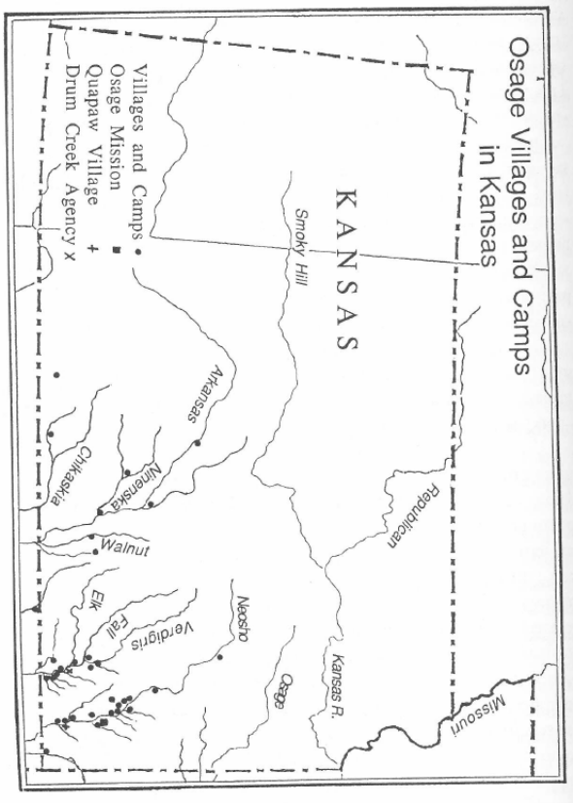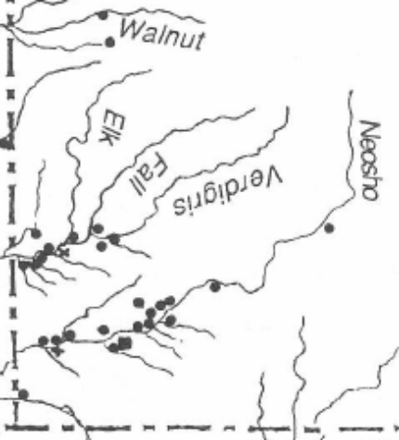
South end of the Neosho “Island” - Vicinity of Trotter’s Ford
Osage Mission
Osage Village

Figure 2: “Osage Villages and Camps in Kansas”, A History of the Osage People, Louis F. Burns, 2004, p. 57
The second of these two maps (Figure 3: “Osage Trails in Kansas”) shows the major east-west trail of the Osage, the “Continental Trail”, entering southeast Kansas and crossing the Neosho River just downstream of where the two branches of the river rejoin at the south end of the Neosho “island”, placing this location, once again, in the vicinity of Trotter’s Ford. In addition, this map shows the “Osage Trace” Trail, running north-south along the western bank of the Neosho River, in line with the series of Osage villages located along the west side of the Neosho River, shown on the first map (Figure 2) above.
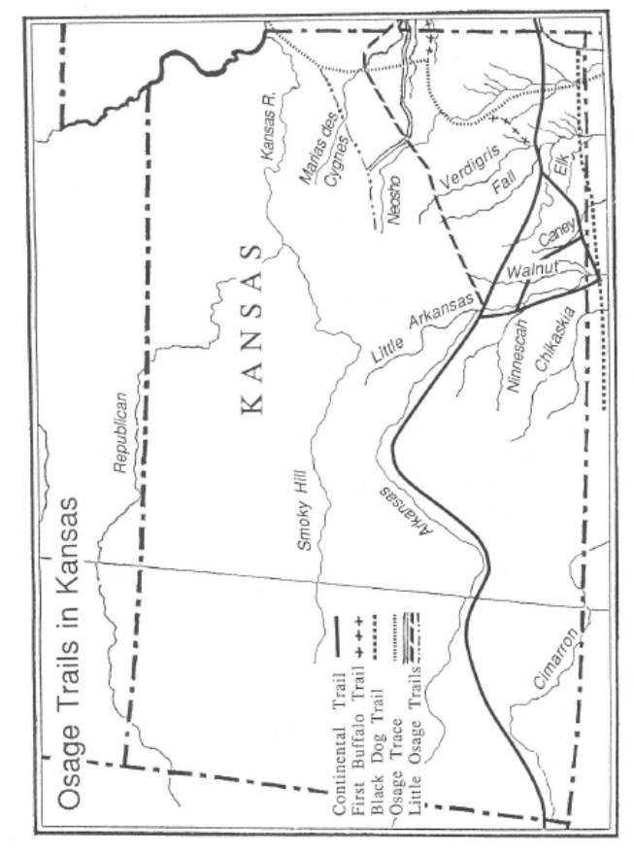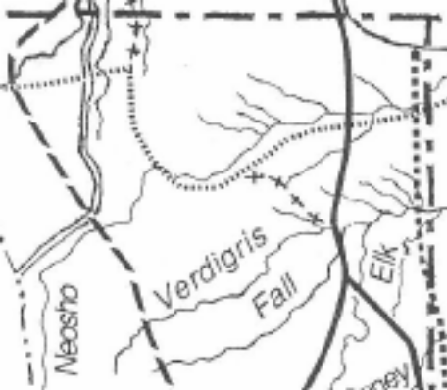
South end of the Neosho “Island” - Vicinity of Trotter’s Ford
Osage Trace
Osage Mission
Continental Trail

Figure 3: “Osage Trails in Kansas”, A History of the Osage People, Louis F. Burns, 2004, p. 76

It is no coincidence then that “early settlers who crossed the river at Trotter’s Ford reported that there were many evidences of an Indian village having been located there”. (History of Neosho County, Vol. I, by W.W. Graves, pp. 21, 22) Even today evidences of such a settlement are still plentiful along the western banks of the Neosho (in Sections 30 and 31, T30S R21E, and Section 25, T30S R20E, of Lincoln Township). Numerous arrowheads, spear points, boat stones, and other artifacts have been found in the river bottom land of this vicinity.
The trails created by the Osage – and the fords that they had used – would become an important asset to the early settlers of southeastern Kansas. As settlers began to arrive shortly after the Civil War, they found no formal roads upon which they could travel. There were a few ferries, but no bridges across the Neosho at Osage Mission until the summer of 1871 – and even then, the earliest bridges (and ferries) were not free – settlers had to pay to use them. (Annals of Osage Mission, W.W. Graves)
One early settler, Francis M. Abbott (1841-1923), wrote: “When I first came to Neosho County (in 1867), not an acre of taxable land, all government land, the Osage Indians here yet, not a railroad within a hundred miles, nor a telegraph line, not a single public school building, no regularly laid out roads, not a mile of hedge fence, no good farm houses or barns or other permanent rural improvements. No stone nor brick buildings, not one. There were two laid-out towns, Erie and Osage Mission. There were no laid-out roads. Many people hardly knew where the section lines were. If a place became too soft or muddy to cross easily, the traveler went a little above or below to cross. There was not a bridge across any stream anywhere in the county.” (F.M. Abbott, Thayer News, 12 December 1913, Vol. 1, p. 290)
Another early settler, Francis M. Dinsmore (1844-1930), also wrote: “I came here in December 1865, soon after I came out of the army, and settled on a claim in the valley of East Lincoln near the cut-off. There were no houses of any kind in that locality then. The blue stem grass was so tall that a man riding on a horse could not be seen fifty yards away. The grass was so thick the deer could not go thru it. They went by leaps over the top… The only roads in those days were trails across the country.” (F.M. Dinsmore, comments reported to W.W. Graves about 1929, Vol. 1, p.298)
Thus, in the absence of any formal roads or bridges, the system of trails and fords used by the Osage became an essential asset to the western migration of settlers into the Neosho River valley. Trotter’s Ford was a prime example of such a route, as indicated in the following historical entries:
- W.W. Graves wrote in his History of Neosho County: “Trotter’s Ford was the name given to an extra good ford on the Neosho River just below where the two branches of the river reunite at the south end of ‘the Island’ (an area bounded on both sides by the Neosho River). The only house in this locality (East Lincoln Township) in 1865 was at this ford, occupied by a quarter breed named ‘Trotter’. Trotter had a store and a grist mill there and also conducted a ferry. (Vol. 1, pp. 296, 297)
- Freight wagons from Kansas City to Independence usually crossed the river at Trotter’s Ford.” (Vol. 1, p. 447)
- During the Civil War mail was brought from Ft. Scott to Osage Mission once a week. Mail shipments further south and west crossed the river at Trotter’s Ford. (A.T. Dickerman, Oswego Democrat, 29 April 1915; Vol. 1 pp. 248-249)
- And in September 1866 (perhaps due to the convenience of the ford’s central location between the towns of Erie and Osage Mission to the north, Jacksonville to the south, and Ladore (Fort Roach) to the west), Trotter’s Ford was selected as the site of the first political party convention in Neosho County. (J.A. Wells, “Condensed History of Neosho County”, Erie Record, summer 1876, Vol. 1, pp. 273-274)
On September 29, 1865, a treaty was finalized with the Osage Indians wherein the Osage ceded two large tracts of land to the U.S. government. The first of these tracts, known as the Osage Ceded Lands, included the Neosho River valley and the land south of Osage Mission. Trotter’s Ford and all the land on either side of the ford, including all of Lincoln Township, were part of this tract. Once this treaty was completed, the flood gates for settlement were opened, and the artery of the Osage Trail that crossed the Neosho at Trotter’s Ford, and that continued through the heart of Lincoln Township, would become the principal highway to pioneer settlement in southeastern Kansas. The fact that the Oak Grove School would be located on this route uniquely placed the school, and all those associated with it, in the middle of a significant historical movement – and in close proximity to several historical events associated with this movement.
Again, no detailed maps of Neosho County exist from this early time frame, but a close examination of the Land Plat Map of Lincoln Township (Figure 4, from the 1906 Standard Atlas of Neosho County) shows that Trotter’s Ford, even forty years after 1865, was still an important, recognized landmark. It is also worth noting that in 1906 there still remained a road that ran west from Trotter’s Ford across the middle of Section 30 (T30S, R 21E), and then turned south at the eastern boundary of Section 25 (T30S, R20E), and then west again at the boundary between sections 25 and 36 (T30S, R20E). The route of this road is notable for several reasons:
- It was the route westward from Trotter’s Ford, the river crossing that was most likely the same crossing used by the Osage as part of the original Osage Continental Trail. (As mentioned before, even today there are evidences of a major Osage presence along this route (in Sections 30 and 31, T30S R21E, and Section 25, T30S R20E, of Lincoln Township). Numerous arrowheads, spear points, boat stones, and other artifacts have been found in the river bottom land of this vicinity.)
- It was very likely one of the primary trails used by early Kansas settlers post September 1865 to migrate westward into southeastern Kansas and beyond.
- The Oak Grove School was located on this route, both in Section 25 (1868-1876) and Section 36 (1877 to present).
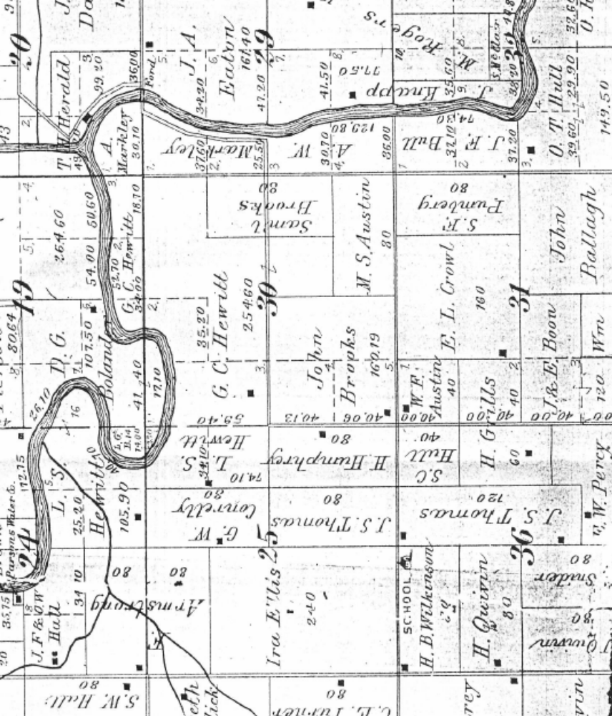
Figure 4: Lincoln Township
Land Plat Map from the Standard Atlas of Neosho County, KS
1906

With author’s added notations to identify historically significant locations
Road to Ladore
Oak Grove School Site
1868 to 1876
Oak Grove School Site
1877 to present
The road west from Trotter’s Ford
Trotter’s Ford
Establishment of the original Oak Grove School: Location and Time Frame (1867-1869)
Pioneer settlement rapidly accelerated in Lincoln Township and all of southeastern Kansas following the Osage Treaty of September 1865. The total population of Neosho County grew from about 1,500 in the Fall of 1867 to 10,223 by the Federal Census of 1870. (History of Neosho County, Vol. 1, pp. 288, 327, W.W. Graves) As these resourceful settlers, many with young families, poured into Neosho County, the demand for rural schools to educate their children soon followed.
- “The first regular school district in Neosho County was organized a short distance east of where the Santa Fe Railroad crossed the Neosho River northeast of Chanute in 1866-1867. It was known as Harmony School District No. 1.” (History of Neosho County, Vol. 1, p. 481, W.W. Graves)
- Valley City School District No. 19 was established in Lincoln Township in 1867. (Ditto, p. 454), and
- Abbott School District No. 25 was established in May 1869 in Chetopa Township. (Ditto, pp. 483-484)
Given that these rural school districts were numbered in chronological sequence as each one was established, it follows that the Oak Grove School District (No. 20) had to have been established sometime between the founding of the Valley City School (No. 19) in 1867 and the Abbott School (No. 25) in May 1869.
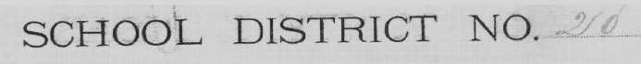
The attached map (Figure 5) shows the boundaries of District 20, enumerating the sections contained therein. This map was recorded in a “Miscellaneous Records Book for Neosho County, 1871-1884” (stored at the Register of Deeds Office at the County Courthouse in Erie). The map appears to have been drawn sometime prior to March 1873 and then later updated in March of 1873 (when additional pencil shading was added to sections 23 and 24) to reflect a boundary change between District 20 (Oak Grove) and District 22 (Mentor) pertaining to the northern quarter of sections 23 and 24.

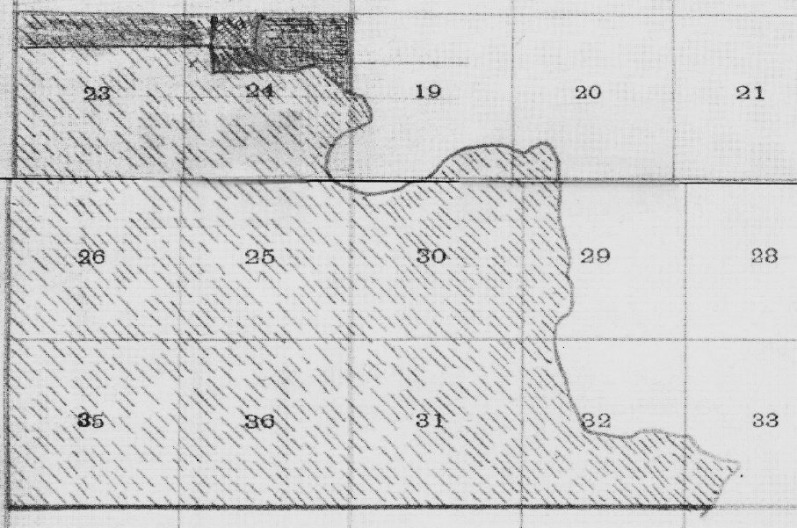
Figure 5:

School District 20 Boundaries, Lincoln Township
Neosho County, Kansas

from
“Miscellaneous Records Book for Neosho County, 1871-1884”

Along with this map, the following accompanying written description of the District 20 boundaries is also recorded in the Miscellaneous Records Book:
District 20 Boundary Description (prior to March 1873): Commencing at the NE corner of Section 24, Township 30 South, Range 20 East, thence South to the Neosho River, thence Southeast in the direction of said River to a point where said River crosses the south section line of Section 33, Township 30 South, Range 21 East, thence West to the SW corner of Section 35, Township 30 South, Range 20 East, thence North 3 miles, thence East 2 miles to the place of beginning.
Revised District 20 Boundary (March 1873): In March 1873 the boundary line between Districts 20 & 22 was so changed as to include the North fourths of Sections 23 & 24, T30S R20E within the limits of No. 22 and all the remainder of said sections within the limits of Dist. No. 20.
Another map (Figure 6) found in the “Miscellaneous Records Book for Neosho County, 1871-1884” at the Neosho County Courthouse in Erie is a very early hand-drawn map of the Neosho County school districts (dated about 1871). This map is marked with pencil dots showing the locations of the schoolhouses for each school district in the county. The facsimile below is a copy of the portion of that map showing the area of District 20. The marking for the District 20 schoolhouse indicates that the original location of the Oak Grove School was in the southeast quarter of Section 25, Township 30 South, Range 20 East, in Lincoln Township. The school location is shown to be about one quarter mile north of the junction of modern day 20th Road and Udall Road in Neosho County, on the west side of the road.
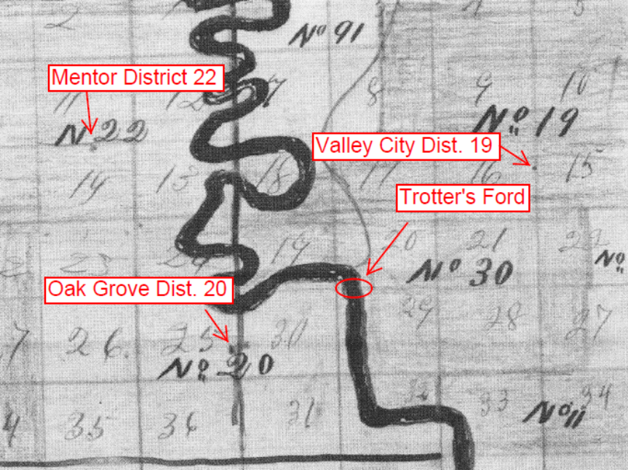
Abandoned Cemetery
Today’s Udall Road
Today’s 20th Road
Figure 6:
Excerpt from “Plat of School Districts of Neosho County Kansas, 1871”
Note: Original hand-drawn map; pencil marks are original and denote locations of schoolhouses in 1871.
This location and time frame of the original Oak Grove School site are supported by the presence of an abandoned cemetery located in the pasture of (the southeast quarter of) Section 25, situated in close proximity to the school site shown on the 1871 map. Known locally as the “Old Oak Grove Cemetery”, the Chanute Genealogical Society inventoried the gravestones of this old cemetery and included that information in a book, “Neosho County Cemeteries”, published in 1978. As recorded in that book, the earliest death dates on the tombstones from this cemetery are from the fall of 1869 (Ellis Stewart, died 19 Sep 1869, and Joseph Rich, died 18 Nov 1869). (Neosho County Cemeteries, Chanute Genealogical Society, 1978, p. 66, Dr. Eric P. Conard)
The adjacency of the old cemetery and the original school site was also supported by oral history from early residents of Lincoln Township who shared this information in reunions of the Oak Grove School in the 1960’s. Three of these residents (George C. Salmans (1879-1964), Charley Kuffler (1912-2001), and Lloyd Pruitt (1921-1998)) specifically recalled seeing the ruins of the original Oak Grove School structure in Section 25, adjacent to the old cemetery, as late as the 1930’s. Another recorded: “The first school of District 20 (in Section 25) was not unlike the present school (in Section 36) in that it too had an adjoining grave yard and the name was Oak Grove, being so named because it was located in an oak forest at the center of the east half of the SE ¼ of section 25, T30S, R20E, on the north bank of a small creek.” (Memoirs of Cary H. Pruitt, Jr., written January 1998) This “small creek” still exists today. It crosses Udall Road approximately 100 yards south of the old cemetery stones in Section 25.
Again, in the absence of any detailed map from the 1860’s, we can turn to the 1906 Land Plat Map to highlight the some of the key names and landmarks associated with the original school site and District 20. Attached below is a section of that 1906 map, showing the area included in District 20, annotated with references to some of the important names and landmarks associated with the Oak Grove School, including:
- Trotter’s Ford and the road leading west from Trotter’s Ford.
- Sections of land owned by George C. Salmans and Charley Kuffler (circa 1930’s).
- The site of the original Oak Grove School (established circa 1867-1869) and the adjacent “old” Oak Grove Cemetery (established circa 1869) in Section 25.
- The site of new Oak Grove School (built in 1877) and the adjacent “new” Oak Grove Cemetery (est. circa 1872).
- The approximate course of the small creek just south of the original school site, extending from Section 25 and across Section 30. (dashed blue line added by author)

Road to Ladore & Independence
5- Small creek south of old school site
Figure 7:
Lincoln Township
Land Plat Map from the Standard Atlas of Neosho County, KS
1906

With author’s added notation blocks to identify historically significant locations
4- Oak Grove School Site
1877
2- George C. Salmans circa 1930’s
2- Charley Kuffler circa 1930’s
1- Trotter’s Ford
3- Oak Grove School Site
1868-1876
3- Old Oak Grove Cemetery
circa 1869
Udall Road
20th Road
4- New Oak Grove Cemetery
circa 1872
1- The road west from Trotter’s Ford
Early Oak Grove School History, 1867-1876
There are few direct references to District 20 during the period of 1867 to 1876 – and no public record references have yet been discovered to an “Oak Grove School” for this period of time - no land purchase records, no newspaper references, no teacher records, or school board meeting records. However, noting the practice with other schools in the county that each school “district” was accompanied by a “school name” when each district was established (e.g. Harmony School District No. 1, Valley City School District No. 19, and Abbott School District No. 25), it is likely that District 20 was also accompanied by the school name of “Oak Grove” when the district was formed. This is corroborated by the previously cited oral history handed down by early residents of the area, the name given to the new school built in 1877, and the name used for each of the cemeteries associated with the school locations in both Sections 25 and 36 – all referring to the name “Oak Grove”.
Neither do we have any direct records of what the structure of the original Oak Grove School District 20 in Section 25 looked like. However, the construction of the school was probably similar to that of other early schools built elsewhere in the county. The Harmony, Valley City, and Abbott schools were all built of logs. The Harmony schoolhouse had a floor “of sawed oak and walnut logs not planed. The seats were slabs with holes bored in the ends and pegs driven in for legs. The roof was of clapboards riven from native logs” (History of Neosho County, Vol. 1, p. 481, W.W. Graves). The Abbott schoolhouse used short logs laid upon the floor next to the wall on which were laid some planks for seats. “The pupils leaned back against the walls. The cracks between the logs were neither chinked up nor daubed with mortar” (Ditto, p. 484). So very likely, the construction of the original Oak Grove School, built in the same period of time as these other schools, was a crudely built log structure, but probably built on a stone foundation (referencing the ruins reportedly seen in the southeast quarter of Section 25 in the 1930’s).
The earliest indication of there being student attendance at the original Oak Grove School is evidenced by the 1870 Federal Census. Several families listed in the census that resided in close proximity to the original school location show to have had children “that attended school within the last year”. One of these families was that of George C. Hewitt (1832 – 1912). George C. Hewitt was one of the earliest settlers in Lincoln Township. According to a newspaper obituary printed in the Parsons Daily Sun on December 12, 1912, George C. Hewitt “relocated his family from Jersey County Illinois, arriving at the cross-roads of the Neosho River on December 15, 1865. He made camp at Trotter’s Ford and a few days later filed (a claim) on the farm on which he would live continuously for more than 45 years” (See Figure 7 – which shows that G.C. Hewitt owned land in 1906 in Section 30, T30S, R21E, of Lincoln Township).
George Hewitt’s home was therefore not only located within the boundaries of Oak Grove School District 20, but his home was located just one quarter mile north of the original Oak Grove School location, on the east side of the road (today’s Udall Road). So it is very probable that the Hewitt children attended the Oak Grove School just one quarter mile away – and in the Federal Census of 1870 (recorded March 1, 1870), George Hewitt is indeed listed as having two children “who attended school within the last year”. Numerous other families that are listed in close proximity to the George Hewitt family (numbered sequentially immediately before or after the George Hewitt dwelling) also list children “who attended school within the last year”. Attendance “within the last year” (as recorded on March 1, 1870) would indicate that children were attending the Oak Grove School at least as early as 1869.

Additional records found in the County Clerk’s office in the Neosho County Courthouse in Erie also show that:
- as of August 5, 1871, 50 school-aged children were living in the District
- as of August 12, 1872, 46 pupils lived or were attending school in the District
- and for the year 1873, George C. Hewitt is listed as the “Director” of District 20, with Wm. Hull as Clerk, and Noah Walters as Treasurer
- (Source: Miscellaneous Records Book, Neosho County Courthouse, 1871-1873)
The Courthouse reference for George Hewitt as Director and William Hull as Clerk of District 20 for the year 1873 is corroborated by another accounting recorded in the personal papers of Gladys Volmer, a granddaughter of William Hull. These papers, handed down to Gladys’ daughter, Eileen McAtee (of Lawrence, Kansas), record the following (verbatim):

“Early Day History of the Oak Grove District No. 20 School”
School Board:
- 1872: R.A. Weir, Wm. Hull, Noah Walters
- 1873: G.C. Hewitt, Wm. Hull, Noah Walters
- 1874: C.W. Bennett, Wm. Hull, Noah Walters
Board members elected:
- August 1875: C.W. Bennett, Wm. Hull, Noah Walters
- August 1876: C.W. Bennett, Wm. Hull, Noah Walters

“On July 16, 1872, D.P. Gardner, L.R. Charles, and G.C. Hewitt appraised land for school site.
Each received $2.00.”
- First building: 1871-72
- Re-built 1877

Source: Personal Papers of Gladys Volmer, granddaughter of Wm. Hull

This information corroborates the 1873 data from the County Clerk’s office in the Neosho County Courthouse in Erie, plus provides additional school board information for the years 1872 and 1874-1876. Moreover, it confirms that the name of “Oak Grove” was indeed associated with School District 20. And, more importantly, the above information confirms that:
- There was a site for the school identified and appraised in July 1872 (either in Section 25 or Section 36).
- A school was built (somewhere) in the period of 1871-1872.
Given that residents of the District 20 area had children attending school in the period of 1869-1870 (per the census records for 1870), the information from Gladys Volmer’s papers could indicate that a temporary school structure existed in the period of 1869-1871 (in Section 25), after which a more permanent structure was constructed in the period of 1871-1872 (either in Section 25 or Section 36).
- The Oak Grove school structure (as we know it today) was indeed built (i.e. “re-built) in the year 1877.

Contemporary Historical Events near the Oak Grove School, 1867-1876
Although records for Oak Grove are scant for the years 1867 to 1876, there is much insight to be gleaned from the contemporary historical events that occurred in close proximity to the school during this period of time. These were some of the roughest and toughest times in southeastern Kansas, and while events of this period would have been a concern for the community at large, they likely would have had an indirect impact upon the school as well (e.g. convening special community meetings to share information or dispel rumors amongst concerned citizens). Consider, for example, the following events that occurred in or near Lincoln Township during this period of time:
July 11, 1869 – The Neosho River floods to its highest level in fifteen years. (Annals of Osage Mission, p. 97)
Sept/Oct 1869 - The Charles Ingalls family arrives in southeast Kansas. Traveling from Missouri, the family settles just west of Independence. (Pioneer Girl, Laura Ingalls Wilder, South Dakota Historical Society Press, 2014, pp.1-22)
May 10-11, 1870 – On May 10 the Katy railroad reaches Ladore (about eight miles west of the Oak Grove School). On May 11 five men are lynched at Ladore for drunken crimes. (The Katy Railroad and the Last Frontier, V.V. Masterson, 1952, pp. 54-56)
October 17, 1870 – The Parsons Town Company is organized. (The Katy Railroad, p. 88)
January 9-11, 1871 – “The first railroad bridge over the Neosho River completed. On January 11 the first train (a construction train) arrives in Osage Mission from Parsons.” (Annals of Osage Mission, p. 137)
February 1871 – The notorious Bender family settles on their farm in Neosho County, about 18 miles west/southwest of the Oak Grove School. (Annals of Osage Mission, p. 176)
Spring 1871 – The Charles Ingalls family departs southeast Kansas, traveling from the Independence area back to Missouri. (Pioneer Girl, Laura Ingalls Wilder, South Dakota Historical Society Press, 2014, pp.1-22)
July 1871 – The Neosho River floods the valley. (Annals of Osage Mission, p. 145) Stone work on new bridge (first bridge) over the Neosho River west of Osage Mission. (Annals of Osage Mission, pp. 141, 146)
April 27, 1872 – Orville S. Grant, brother of President Ulysses S. Grant, visits Osage Mission. (Annals of Osage Mission, p. 160)
December 25, 1872 – Snow falls two feet deep in Osage Mission. Thermometer registers 14 below zero on December 23rd. (Annals of Osage Mission, p. 171)
January 22, 1873 - The Neosho River valley floods. (Annals of Osage Mission, p. 173)
January 29, 1873 – The thermometer registers 22 degrees below zero. (Annals of Osage Mission, p. 173)
May 1873 – The notorious Bender family disappears.
June 1873 – “Chinch bugs completely ruined many wheat fields.” (Annals of Osage Mission, p. 179)
May 22, 1873 – Tornado hits east Lincoln Township, leaving a path of destruction “five miles long and half a mile wide (that) was swept clean of every building or improvement”. (Annals of Osage Mission, p. 177)
Fall 1874 – Grasshopper epidemic hits Neosho County, “devouring everything green”. (Annals of Osage Mission, p. 199)
May 10, 1876 – The Neosho River floods the low lands west of Osage Mission. (Annals of Osage Mission, p. 227)
As indicated by this sampling of events, life was a hardscrabble challenge for the early settlers of southeastern Kansas, and more specifically, for those in Lincoln Township. Flooding of the Neosho River was frequent. Winters were cold. Tornadoes, grasshoppers, and chinch bugs had a way of promptly destroying months of hard work by the farmer. But as also indicated, these were interesting times with significant historical developments and accompanying characters – and those who lived in the vicinity of the Oak Grove School were in the middle this active period of change.
The Osage treaty of September 1865 opened the doors for farmers and settlers, but the release of the Osage lands also paved the way to industrialization of the prairie and the advent of the railroad. The competition between railroad companies to lay tracks into southern Kansas and onward through Oklahoma Territory and Texas reached a fever pitch during the period of 1867 to 1876. The availability of land for settlement combined with the thrust of railroad competition introduced an array of influences, both reputable and disreputable, into the region of southern Neosho and northern Labette counties that would have undoubtedly impacted the Oak Grove School and those associated with it.
By the spring of 1870, “immigrants, honest settlers, squatters, promoters, adventurers, all accompanied by the lowest riffraff of the frontier, were flooding into southern Kansas in the wake of the railroad. The removal of the Indians to new homes south of the Kansas line appeared imminent, and squatters were swarming over the reservations in droves, pre-empting the best sections without a legal right. The Indians, and indeed the Indian agents with all the prestige and authority of the federal government, were powerless to prevent the influx of the hungry land-seekers.” (The Katy Railroad and the Last Frontier, V.V. Masterson, 1952, p. 55)
Three notable events associated with this influx of immigrants occurred in relatively close proximity to the Oak Grove School: the lynching of five hooligans at the railroad town of Ladore (May 1870), the Bender family murders and their mysterious disappearance (1871-1873), and the temporary settlement of the Charles Ingalls family (of “Little House on the Prairie” fame) near Independence (1869-1871). A review of the potential collateral impact of each of these events upon the Oak Grove School community follows below.
Oak Grove and the Story of the Lynching at Ladore
There is no greater example of the riffraff that flooded into southern Kansas “in the wake of the railroad” than the story of the lynching at Ladore. While the Oak Grove School had nothing directly to do with Ladore, the community of Ladore was only eight miles west of the Oak Grove School – and many of the immigrants who sought work on the railroad and in the communities developing around it (e.g. Ladore and Parsons) would likely have crossed the Neosho River at Trotter’s Ford, and then followed the old Osage Continental Trail westward to Ladore – driving their teams and wagons right past the Oak Grove School. Students at the Oak Grove School would have been well aware of the coming of the railroad, for it is likely that they would have encountered people heading toward Ladore on a daily basis in the weeks leading up to May 1870.
Uniquely located at the point where the Katy railroad crossed the well-traveled Osage Continental Trail, Ladore was a rough-and-tumble railroad terminus camp. “It was a log-cabin, board-shanty, tent town that aspired to become the division point of the Katy railroad’s projected Sedalia division… The day the track reached Ladore (May 10, 1870) was probably one of the wildest in the history of the West.” A report by L.A. Bowes, a track foreman for the Katy, portrayed these conditions with the following account: “Ladore was the toughest place I ever struck. Whiskey was sold in nearly every house in town. Vice and immorality flourished like a green bay tree. At noon (on May 10, 1870) seven hard-looking characters came into town. They commenced to fill up on Tangleleg. That evening about dusk they began operations by knocking men down and robbing them. As they were heavily armed, they soon had full possession of the town and had everything their own way during the night… Along towards morning the citizens began to organize for the capture of those devils. We locked the men up in a log barber shop, put a guard over them, took them out one by one…, and swung them up on a large projecting limb of a hackberry tree. By eleven o’clock five men hung lifeless on that one limb.” (The Katy Railroad and the Last Frontier, V.V. Masterson, 1952, pp. 54-56)
So significant was this event in the lives of those who lived in the Oak Grove community (and of the entire local area), that the story of the lynching at Ladore has been vividly retold amongst Lincoln Township residents for years – and the story remains part of local folklore even today.
Oak Grove and the Notorious Bender Family
Another example of the “lowlife” that found its way into southeastern Kansas during this time was that of the notorious Bender family. The Benders (John, Elmira, John Jr., and Kate) settled in the northeast quarter of Section 13, T31S R17E, Osage Township, Labette County, in February 1871 - about 18 miles west/southwest of the Oak Grove School. The family built their wood-framed “inn” alongside a well-traveled branch of the Osage Trail that ran (southwest to northeast) between Independence and Osage Mission (see Figure 8: “Location of Bender Claim”).
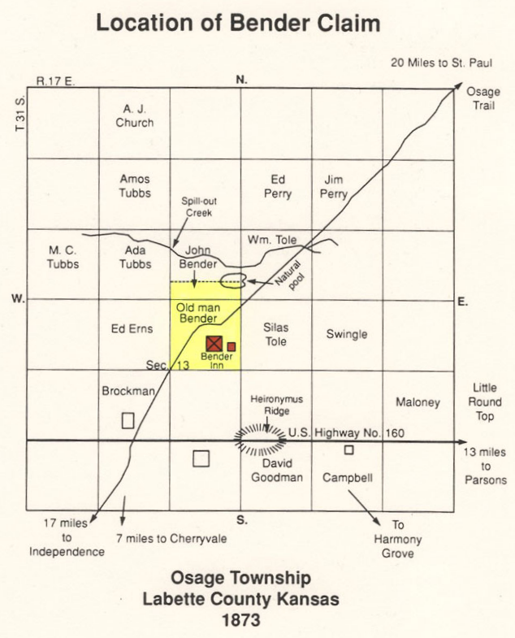
Ladore: 8 miles
Oak Grove School: 16 miles

Figure 8:
Location of
Bender Claim
Osage Township
Labette County Kansas
1873

“The Benders -
Keepers of the Devil’s Inn”
By Fern Morrow Wood,
1992, p. 58
There is no need to rehearse the details of the Bender story here, but it is worth noting that:
- the atrocious Bender murders were committed during the period of time between February 1871 and the ultimate disappearance of the Bender family in June 1873, and
- the people who fell victim to these crimes were travelers along the Osage Trail, journeying between Independence and Osage Mission (and Fort Scott).
As already documented, the Oak Grove School was definitely in operation during this period of time (with attendance having begun at least as early as 1870, and with George C. Hewitt recorded as “Director” and Wm. Hull as “Clerk” in 1873). Moreover, with the Oak Grove School having been located on a major branch of the Osage Trail (the Continental Trail), it is very possible that some of the travelers who fell victim to the Bender atrocities – and perhaps even the Benders themselves – may have traveled the road that passed by the Oak Grove School.
The branch of the Osage Trail where the Bender property was located was also referred to as the “First Buffalo Trail” (“Pioneer Girl, Laura Ingalls Wilder”, South Dakota Historical Society Press, 2014, p. 1). A traveler on the First Buffalo Trail, enroute to Osage Mission/Fort Scott, would somewhere along the way have intersected the (east-west) Osage Continental Trail as well as the (north-south) Osage Trace trail (that paralleled the Neosho River) (compare Figure 3: “Osage Trails in Kansas” and Figure 9: “Map of Kansas, Missouri, and Indian Territory, 1869-1871”). Travelers journeying from Fort Scott to Independence would have had two choices of routes to follow – one via Osage Mission, and the other via Trotter’s Ford.
Following the disappearance of Dr. William York (the last Bender victim), Dr. York’s brother, Colonel Ed York of Fort Scott, “led a company of some fifty men, and conducted a search for his brother, questioning every traveler along the trail and visiting all the area homesteads” (“The Benders - Keepers of the Devil’s Inn”, Fern Morrow Wood, 1992, pp. 31-33). A thorough search of this type would most certainly have included an investigation of both alternative routes - so it is possible that at least some of those who lived in the Oak Grove School community could have been among those who were directly visited by Colonel York’s search party.
Again, so significant were the atrocities committed by the Bender family, and so close in proximity was the Bender site to the Oak Grove community, that the story of the “Bloody Benders” became yet another part of the folklore retold by early Lincoln Township residents throughout the years that followed. Even at reunions of the Oak Grove School in the 1960’s there were retold many variations of conjectural tales of how the Bender family met its ultimate demise, and how pioneer members of the Lincoln Township community took part in the posse that pursued and secretly executed the members of the Bender family.
Oak Grove and the Laura Ingalls Wilder Family
A third potential connection of historical interest contemporary with the Oak Grove School is one on the brighter side – it is the story of the Charles Ingalls family traveling to southeast Kansas and settling on a claim of property just a few miles west of Independence between the years of 1869 to 1871. The geographical setting of the Ingalls cabin is shown in the map of Figure 9 below. This map shows not only the location of the Ingalls cabin, but also the Bender’s Inn, the First Buffalo Trail (Independence-to-Fort Scott Trail), the Osage Trace (Great Osage) Trail, and the approximate location of Trotter’s Ford in relation to each of these significant landmarks.
What is particularly interesting about the Ingalls family presence in Kansas as it relates to the Oak Grove School are the circumstances surrounding the family’s return to Missouri in 1871. Laura Ingalls Wilder wrote about their family’s departure from southeastern Kansas in her autobiography, “Pioneer Girl”. This story and the circumstances surrounding it have been meticulously reviewed and annotated by the South Dakota Historical Society Press (2014). The family departed their squatter’s cabin west of Independence, Kansas, sometime in the spring of 1871. After having passed Independence on their way east, Laura wrote:

“All the neighbors went with us for a while, then they scattered but we went on into Missouri. It was bad going for it rained making the roads muddy and the creeks and rivers high.”
Laura then proceeds to tell the story of the family’s crossing of a particular river with high water. After crossing the river with some difficulty, the family then stops and rests for the entire next day – her comments continuing as follows:
“We waited then for the weather to settle and the waters to go down. We stayed for a while in a log house with a big fireplace. Pa worked for the man who owned the house so we were alone with Ma all day.”
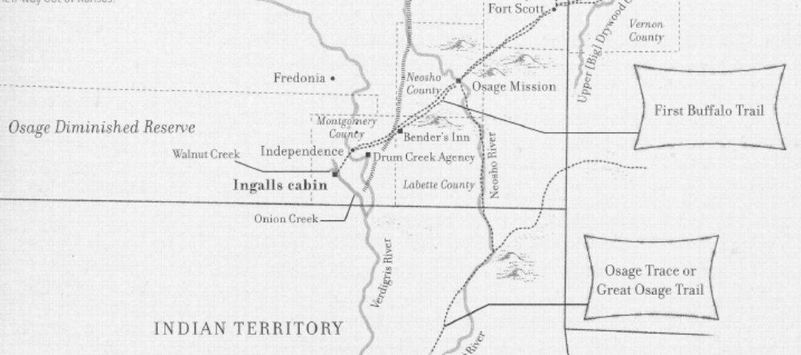
Leavenworth, Lawrence & Galveston Railroad
Vicinity of Trotter’s Ford
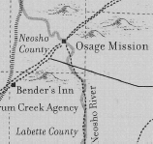
Osage Continental Trail (Approximate route)
Figure 9:
Map of Kansas, Missouri, and Indian Territory,
1869-1871

Source: “Pioneer Girl, Laura Ingalls Wilder”,
South Dakota
Historical
Society Press,
2014, p. 1

With author’s additions of the Osage Continental Trail and notations identifying historically significant locations
Vicinity of Trotter’s Ford

The analysis by the South Dakota Historical Society Press concludes that this event occurred somewhere close to the Missouri border, but with the following caveat commentary:
“It is unclear where the Ingalls family entered Missouri, or which swollen river they crossed, but it is interesting to speculate. A.J. Johnson’s map of Kansas and Nebraska, published in 1870, shows no roads leading out of Independence, Kansas, toward Missouri. In fact, the map indicates only one road out of Independence – heading north toward Fredonia. This lack of roads is not especially surprising; Montgomery County was, after all, part of the Osage Diminished Indian Reserve. But if the Ingalls family had traveled northeast into Neosho County, Kansas, they could have found a road that cut northeast through Bourbon County, Kansas, to Fort Scott, and from there into Vernon County, Missouri.”
The South Dakota Historical Society Press then adds these additional clarifying remarks in an annotation to the map shown in Figure 9:
“This map (Figure 9) shows the region in which Charles Ingalls built the family cabin in 1869. While established settlements and political boundaries can be pinpointed with accuracy, the region’s trails, which varied over time, are more difficult to place with precision. The routes of the Osage Trace and the First Buffalo Trail are approximations based on numerous historical maps and secondary sources. The Osage Trace was a combination of several trails. The segment depicted on this map was also known as the Military Road or the Fort Leavenworth to Fort Gibson Road. The First Buffalo Trail was also called the Osage Trail. It represented a spur off from the main Osage Trace between the approximate locations of Independence and Osage Mission, where it merged with or paralleled the Osage Trace. It is possible that the Ingalls family followed the First Buffalo Trail on their way out of Kansas.” (“Pioneer Girl, Laura Ingalls Wilder”, South Dakota Historical Society Press, 2014, p. 1)
If indeed the Ingalls family journeyed from the Independence area to Fort Scott, then the most direct path for them to follow would have been the First Buffalo Trail, leading them to Osage Mission. However, there are some additional factors to consider in determining their actual route – and as suggested by the Historical Society Press, “it is interesting to speculate.” Consider the following:
- The Ingalls family was poor. They had very little money to spend. Settlers typically had to pay a toll to cross a river by bridge or ferry. Such was the case at Osage Mission.
- However, there was no toll to cross a river at a natural ford. And Trotter’s Ford across the Neosho was “an extra good one” (W.W. Graves). Settlers who had already journeyed westward across the Neosho would have known this when returning eastward.
- The “north-south” First Buffalo Trail would have crossed the “east-west” Continental Trail before reaching Osage Mission – and at that point, the Ingalls family could have turned east and headed straight for the crossing at Trotter’s Ford on a well-traveled trail.
- The river crossing mentioned in the Ingalls’ story appears to have occurred in a rural location. After crossing the river, they spent the next day in a “log house”, not in a town. Yet, while Laura and her mother and sisters rested, Charles Ingalls “worked for the man who owned the house”.
- There was a house at Trotters’ Ford. There was also a grist mill in 1871. And it was a rural location (no town). It is conceivable that Charles Ingalls could have secured temporary employment for the day at the grist mill – which was owned by the same person who had a cabin at Trotter’s Ford.
- The Neosho River is prone to flooding, so it would stand to reason that the Neosho was running high during this period when it was raining and “making the roads muddy and the creeks and rivers high.”
- Laura Ingalls Wilder relates this story sequentially to their departure from Independence – and as the very next thing that occurred following their separation from the main body of their neighbors, after which “they (the neighbors) scattered but we (the Ingalls) went on into Missouri.” This separation could well have occurred at the intersection of the north-bound First Buffalo Trail and the east-bound Continental Trail. After the Ingalls headed east from that point, the very next river crossing would have been the Neosho – at Trotter’s Ford.
With all the above considered, there is certainly the “possibility” that the Charles Ingalls family drove their wagon right past the front door of the Oak Grove School house on their return journey to Missouri. This may never be proven, but it is still “interesting to speculate” – and Trotter’s Ford would appear to be as good a candidate for this story as any other.
Conclusions Regarding Early Oak Grove History, 1867-1876
The composite of all the records and oral recollections regarding the early history of the Oak Grove School, the history of the Osage Indians in Neosho County, and the early history of pioneer settlement and development of the railroad in southeastern Kansas strongly support the following conclusions:
- The first Oak Grove school house was founded about 1867/1868 and was located in the southeast quarter of Section 25 of Lincoln Township on the road that led from the Neosho River (at Trotter’s Ford) westward toward Ladore and Independence. The path of this trail essentially proceeded west from Trotter’s Ford to today’s Udall Road, then Udall Road south to 20th Road and then westward toward Ladore.
- Trotter’s Ford and the trail that crossed it were a legacy of the Osage – very likely part of the Osage Continental Trail – and, in the absence of any formal roads or river crossings, this ford and trail were one of the routes heavily used by the early settlers migrating into southeastern Kansas.
- The early settlers of School District 20, Lincoln Township, lived in the midst of a hyper-active period of settlement and development in southeastern Kansas. They lived physically close to the historical events of this period and were located on a main thoroughfare of transit that may have been traveled from time to time by some of the players in these events. The tales these early settlers handed down to their descendants for years thereafter are indicative of the influence these events had upon their lives.
Something happened toward the end of 1876 that led these early settlers to relocate the original Oak Grove School from Section 25 to Section 36. Whatever the reason for this change, the new school structure that would result from this relocation would become the center of society in Lincoln Township for the next 80 years.

Relocation and Reconstruction of the Oak Grove School (1877)
In the year 1877 the Oak Grove School was relocated from Section 25, T30S R20E to a one acre site in the NE corner of the NW quarter of Section 36, T30S R20E (the NE ¼ of the NE ¼ of the NE ¼ of the NW ¼ of Section 36, Township 30S Range 20E). This date is substantiated by the aforementioned personal papers of Gladys Volmer, granddaughter of Wm. Hull, which stated that the school was “Re-built (in) 1877”. This date is further corroborated by a two-foot by three-foot sandstone marker embedded on the front (east wall) of the school, about 5 feet above the door, which bears the following inscription: “Oak Grove, District No. 20, 1877”.
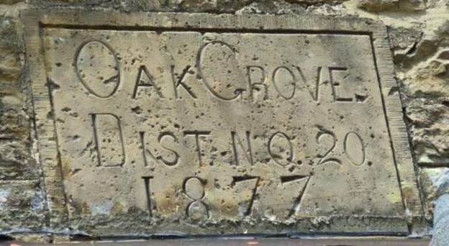
“G.C. Osgood”
OAK GROVE
DIST. NO. 20
1877

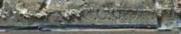
Interestingly, the lower right-hand corner of this marker bears the inscribed name of “G. C. Osgood”. This inscription appears to refer to “George Clark Osgood”, a stone mason who in 1877 was living just a short distance west of the Oak Grove School in the North Township of Labette County. George Clark Osgood migrated from Saranac, Michigan to the Parsons, Kansas area sometime between 1870 and 1875. His occupation was recorded as a “stone mason”, age 22, in the 1870 federal census in Saranac, Ionia, Michigan. He then appears, at age 27, in the 1875 Kansas state census for North Township, Labette County. His name is listed again in the 1880 federal census of North Township, Labette County, at age 32, with occupation as a “brick layer”.

It thus appears that George Clark Osgood was the lead stone mason in the building of the Oak Grove School in 1877. To what extent George Osgood was involved in the construction of any other schools in the area is not known, but in 1884 he was contracted by the city of Parsons to build a bridge over Labette Creek on the east side of town, extending Morgan street eastward to the Oakwood Cemetery (see newspaper clipping of Parsons Daily Sun, dated September 26, 1884). And on December 20, 1884, George Osgood “laid out an addition to Parsons on high ground just across (east) the Labette Creek” (http://parsonskansashistory.com/).

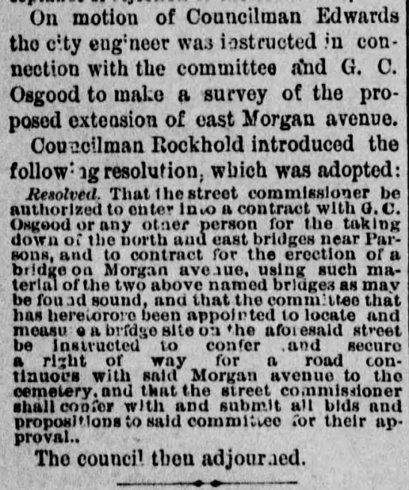
Source: Parsons Daily Sun, Sept 26, 1884

By the early 1890's, George Osgood had moved west to Bellingham, Whatcom County, Washington, where he had a major role in building the Bellingham City Hall (which still stands today). He lived out his life in the Bellingham area and is buried along with his wife, Nancy Collins Osgood, in the Bayview Cemetery in Bellingham. George Clark’s family genealogy yields two notes of interest: (1) George Clark Osgood’s grandfather, David Osgood, served as a captain in the Revolutionary War, and (2) his grandfather’s cousin was Samuel Osgood, the first postmaster general of the United States under George Washington.
No early photographs showing the original appearance of the Oak Grove School as it was built in 1877 have yet been found. However, one late-1800’s era photo has been found of another stone school, the Mentor School (District 22), which was also built of native Bandera sandstone, and which was located just three miles north and one mile west of the Oak Grove School. Unfortunately, the Mentor School is now in ruins, but it is illustrative to compare the early photograph of the Mentor School to the Oak Grove structure, as the Mentor School likely bore a very strong resemblance to what the original Oak Grove School would have looked like in the late 1800’s. Both schools were built in the same period of time, shared social and scholastic events together, and also shared school district boundaries (Oak Grove (District 20) and Mentor (District 22)), which boundaries were occasionally adjusted to balance pupil attendance between the two schools. The only structural difference between the two schools was that the Mentor School had four windows on each side while the Oak Grove School has only three windows on each side. This early picture of the Mentor School is attached below (on the right), juxtaposed to a current picture of the Oak Grove School (on the left) from a similar orientation.
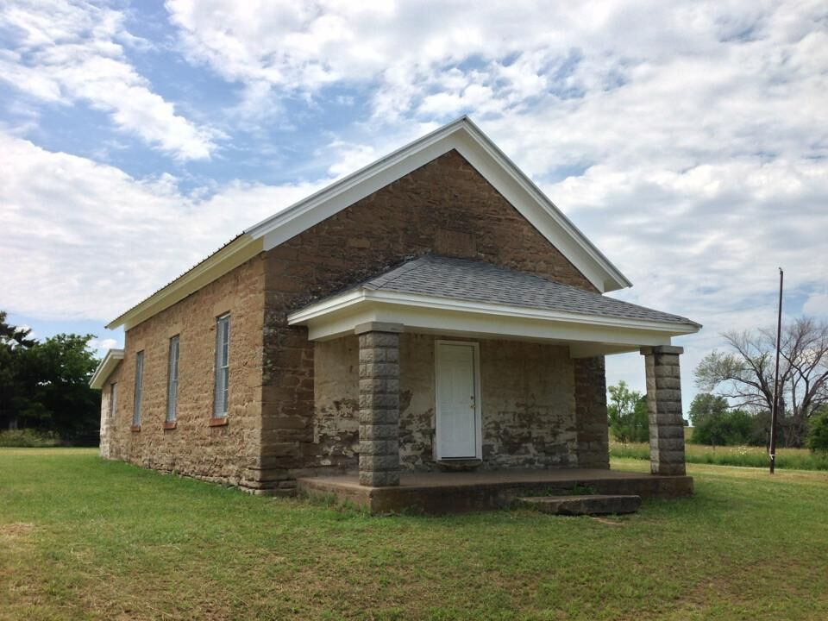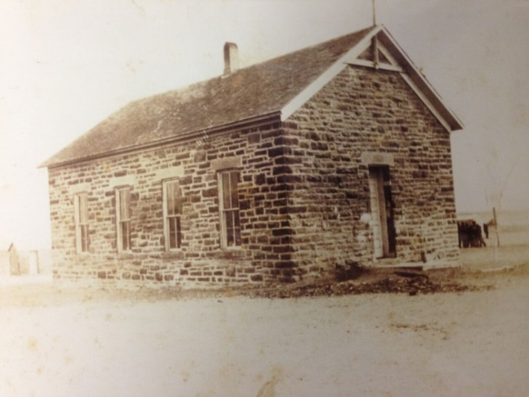
Oak Grove School, District 20
Built in 1877
As it appears today (2015)

Mentor School, District 22
Located 3 miles north and 1 mile west of Oak Grove
Picture from late 1800’s

Like the early picture of the Mentor School, the original Oak Grove School did not have a covered front porch. The front porch was built in the summer of 1913. At the time of the porch construction, a large sandstone slab that had served as the front doorstep to the Oak Grove School (similar to the slab that is shown at the foot of the front door in the photo of the Mentor School) was moved out to the front edge of the covered porch to serve as a step up to the porch floor. That original sandstone slab, measuring about 5 feet long by 4 feet wide and 12 inches thick, remains at the front edge of the Oak Grove porch today and can be seen in the picture above.

The stone that was used for the building of the Oak Grove school was native sandstone local to the area. The quarry site has not yet been found, but stories handed down from early settlers of Lincoln Township related that the quarry site was about one quarter mile to the north of the school (in Section 25).
Again, the exact reason for the relocation of the Oak Grove School in 1877 is unknown. One possible reason may have been related to flooding in the school site area of Section 25. Oral history passed along in the 1960’s indicated that the original location of the Oak Grove School (and the adjacent “Old Oak Grove Cemetery”) in Section 25 were very prone to flooding from the swollen waters of the Neosho River. Indeed, there were significant floods of the Neosho in the years 1869, 1871, 1873, and 1876 – and such flooding continues to be a problem even today. This oral history related that as a result of this flooding, snakes and disease were considerable problems in the area and that perhaps some of those buried in the Old Oak Grove Cemetery had even succumbed to these issues – and that these reasons led to the school being relocated to higher ground in 1877. Reference to this issue was made in the book “Neosho County Cemeteries, Chanute Genealogical Society, 1978”, wherein the background for relocating the Old Oak Grove Cemetery in Section 25 to the site of the new Oak Grove Cemetery in Section 36, was cited as follows:
“Originally used as one of the earliest cemeteries here. It (the Old Oak Grove Cemetery) was abandoned in favor of the “Oak Grove” or Hewitt Cemetery, located next to the Oak Grove School in Section 36. Mrs. E.W. Lamb, who lived nearby in that section, said some of the bodies were re-interred in the new Oak Grove or Hewitt Cemetery. Mrs. Lamb further said that there is a large pile of stones indicating a burial lot on the east end of the old cemetery. This contains a husband, wife and two children, all of a family who died of a contagious disease in the middle 1870s. They were buried away from the rest and stones piled on top of the graves make it noticeable. There are no markers and their identity may not be known.”
Source: Neosho County Cemeteries, Chanute Genealogical Society, 1978, p. 66, Dr. Eric P. Conard

Another possible contributing factor to the Oak Grove School being relocated in 1877 may have been the final resolution of land litigation disputes with the railroads. Throughout the years from 1865 to 1876, Neosho County residents were impacted by “the blight of (the) railroad land monopoly (that) hung over all of private and public enterprises. The odd numbered sections all over (the) district were claimed by the railroads, and were in litigation till 1876.” (F.M. Abbott, a very early teacher in Neosho County, Erie Record, 23 August 1895; Vol. 1, p. 485) This end of litigation may have led to the land in Section 25 being cleared for homesteading – and thus the school being moved to Section 36, since sections 16 and 36 had been “reserved for state school purposes, in accordance with the provisions of the act of admission of the state of Kansas (of the Osage ceded lands)” (per a joint resolution of Congress, dated April 10, 1869) (Source: Kansas Historical Collections, Volume V, pp.69-71).

This possible motivation for relocating the school is echoed in a memoir from Cary H. Pruitt, Jr., a former student of Oak Grove, and a descendant of an early Lincoln Township family:

“These people (the settlers who founded Oak Grove) were squatters and did not own the land (in Section 25) so when Kansas became a territory the land was surveyed and one acre of land was provided nearby (in Section 36) for the location of the present school building. Soon afterwards the location (in Section 36) was accepted by the school board members and building plans were made. After the building’s completion one acre for a playground and one acre for a new cemetery were acquired making a three acre plot in total.”
Source: Memoirs of Cary H. Pruitt, Jr., dated January 1998
Early History of the Oak Grove School, 1877-1899

The only records we have of the Oak Grove School for the years 1877-1880 are the following listings of the school board members for those years:

- 1877: Wm. Hull (Post office: Parsons), District School Clerk, District 20
Source: Neosho County Journal, 12 Dec 1877, Osage Mission, Kansas

District Director, Clerk, and Treasurer:

- 1878: Andrew Lortz, Wm. Hull, Phillip Grommet - (elected August 8, 1878)
- 1879: Andrew Lortz, Osker Hall, P. Grommet
- 1880: Noah Walters, O.W. Hall, Phillip Grommet
Source: Personal Papers of Gladys Volmer, granddaughter of Wm. Hull

For the years 1880 forward, the school board members, their elections, and the minutes of their meetings are fully recorded in the Clerk’s Record Book for the Oak Grove School, District 20. There are several school record books that have survived the years of wear and tear of the non-climatized prairie school environment which document the administrative and financial transactions of the school from 1880 forward. Remarkably, these records are in fairly good condition. Although there are gaps in the 1880-1960 timeline for these records, a significant amount of information has survived, and in the absence of pictures from the late 1800’s and early 1900’s, the entries in these books provide a verbal glimpse into the people and environment of the early days of the school. These records are as follows:

- The Treasurer’s Record Book, December 1880 - July 1947
- The Clerk’s Record Book (of school board meetings), August 1881 - April 1921
- Register of Teachers Employed, November 1880 – June 1960
- Visitors’ Register, 1883 -1886, 1909 - 1915
- Grade Reports (for just a few years after 1900)
- Reunion Visitors’ Register, August 1966 – August 1984

No newspaper articles or other historical records have been found that make any direct reference to the Oak Grove School for the period of 1877-1899. However, there are a few newspaper articles during this period that do make an indirect reference to the school, such as burials at the Oak Grove Cemetery for family members of those associated with the school (e.g. the interment of an infant child of P.A. Grommet (School Board Treasurer 1878-1880), Parsons Daily Sun, July 15, 1886) and to church meetings or baptisms held at the nearby Trotter’s Ford.

Some interesting excerpts from the Clerk’s Record Book of school board meetings for these years describe structural changes indicate the following:

- School Board Meeting, August 9, 1883: "On motion it was voted that the District build a fence around (the) schoolhouse the coming year to be built as follows: 3 barb wire on N and E side and 1 wire (smooth) on W and S side.”
- School Board Meeting, June 28, 1888: “On motion it was voted that the District Board be authorized to buy the schoolhouse grounds.”
- Annual School Board Meeting, July 25, 1895: “On motion it was voted that the Director be instructed to purchase a flag and float the same over the schoolhouse by the commencement of the winter school.”
- Annual School Board Meeting, July 30, 1896: “Motion by Noah Walters that the board employ some person to trim the grove.”
- Annual School Board Meeting, July 29, 1897: “Motion carried that the school board be instructed to build a cistern to be completed by the 1st of October.”
- Meeting of District Board of School District No. 20, August 14, 1897: “Voted that the cistern to be built be made six feet by ten feet (6 x 10) on the inside. Voted that we postpone letting the contract for making the cistern until August 21, 1897, on account of changing the dimensions, etc.”
- Annual School Board Meeting, July 28, 1898: “The School Board was instructed to have a new roof put on the schoolhouse. The Clerk was instructed to write letters to various school desk supply houses for quotation on school desks.”
- School Board Meeting, August 27, 1898: “Mr. Caskey was given the contract of re-shingling the schoolhouse at seventy-five cents per M. Clerk was instructed to order three (3) school desks (two No. 2 and one No. 4) from Sherwood & Co., Chicago, Illinois.”
- Annual School Board Meeting, July 27, 1899: “A motion was made and voted to build a stone coal house.”

In August 1966, Susie (Thomas) Pruitt (1885-1972), who attended the Oak Grove School from 1892 to about 1904, reflected back upon her experience as a young girl attending Oak Grove during the 1890’s.

“Many, many times as if neared 4pm, I’d run past the barn, look down the hill towards Oak Grove and watch for the older school children to come home. Away I would run to join them – I just couldn’t wait until I was one of them. Then, the big day arrived and I went to school. Oak Grove supplied me with my education and entertainment. I feel I owe an awful lot to my early training at Oak Grove.”
Source: The Parsons Sun, Thursday, July 21, 1966, p. 10

Susie Thomas leveraged her education at Oak Grove to become a school teacher herself, going on to teach school at one-room schools in Labette County, and reportedly even substituting at times as a teacher at Oak Grove in the early 1900’s.

The Oak Grove School, a Remarkable Center of Rural Southeast Kansas Society, 1900- 1945
“Oak Grove was the only social life we had. It was our church and Sunday school, also church revivals. We had literaries and debates, Christmas programs, spelling bees, pie suppers, box suppers, last day of school programs and dinners, and also funerals – everything but a wedding – Oak Grove never had a wedding. Oak Grove District 20 means so much to us as we have a lot of happy memories of Oak Grove.”
Source: Frances (Salmans) Fought
Oak Grove Student, 1912-1920
Letter dated May 24, 1988

This letter from Frances (Salmans) Fought epitomizes the importance of the Oak Grove School to the residents of Lincoln Township in the late nineteenth/early twentieth-century. During that era, the Oak Grove School was the center of society for the residents of Lincoln Township. As described in this excerpt from her letter, Frances Fought portrayed Oak Grove as something more than just a school. It was also used for church and Sunday school. It was the site of social events, scholastic competitions and celebrations, and even funerals. It was the center for local stump speeches for candidates of county and state political offices. It was also used as a voting precinct site. And contrary to Frances’ statement, Oak Grove may have also been a site for local weddings and wedding celebrations:
“From 1877 until it was closed, the old structure was the focal point of the Oak Grove community functions which ran the gamut from the gaiety of weddings to the solemnity of funerals. In between were lively ‘literary’ meetings, box suppers and other general events for which it was the logical meeting place.” Source: Martin Thomas
The Parsons Sun, August 7, 1977

“Oak Grove: A large party of Oak Grove folks enjoyed the charivari (chivaree) given for the benefit of William Thomas a few days ago.”
Source: The Parsons Sun, November 17, 1904

Numerous local newspaper articles recorded in the early 1900’s referred to social and political events being held at the Oak Grove School. One of the most significant examples of these was dated August 6, 1904:
“E.W. Percy, residing nine miles east of this place, was in the city today and told of the big picnic that is to be held at Oak Grove on the 14th of this month. Mr. Percy is the superintendent of the Sunday school and his school, a year ago, decided to have a picnic every year. Last season was the first of the picnics. He believes this will be a great picnic as the last one was attended by over a thousand people and this year that number will likely be doubled.”
Source: The Parsons Sun, August 6, 1904

This is a remarkable event places an exclamation mark on the importance of the Oak Grove School to the residents of Lincoln Township. An attendance of over a thousand people – even twice that number – on the grounds of the school would have been a huge event! Aside from the number of people, one can only imagine the number of wagons, buggies, and horses that had to be accommodated.
The importance of the Oak Grove community was also visible enough for politicians to invest campaign time there.
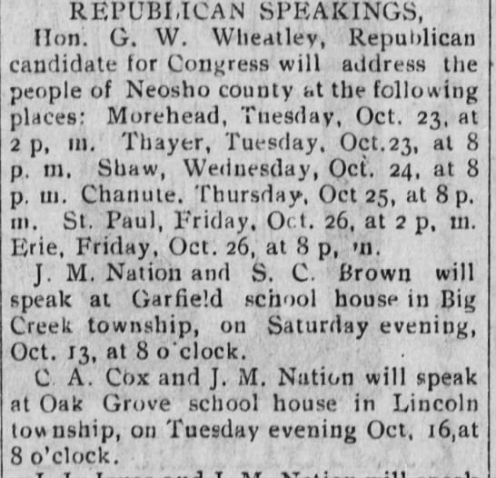
Source: The Sun (Chanute, Kansas),
October 13, 1900, Page 3

The J.M. Nation mentioned in the article above was James Milton Nation. He was elected to the Kansas State House of Representatives from Neosho County in 1901 and 1903. C.A. Cox was elected to the Kansas State House of Representatives from Neosho County in 1895. Both may have been campaigning for G.W. Wheatley for Congress in the 1900 election.
These newspaper clippings regarding Oak Grove are some of the more notable samples of entries that appear in the local newspapers for the period of 1900 forward – but there are many more.
School pictures from 1912 through 1942
See pictures at www.oakgroveschoolhouse.org

Appendix - Miscellaneous
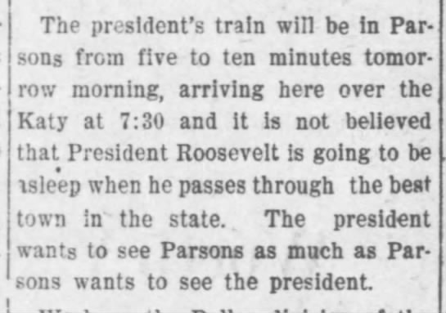
The Parsons Daily Sun
(Parsons, Kansas)
4 Apr 1905, Tue • Page 4

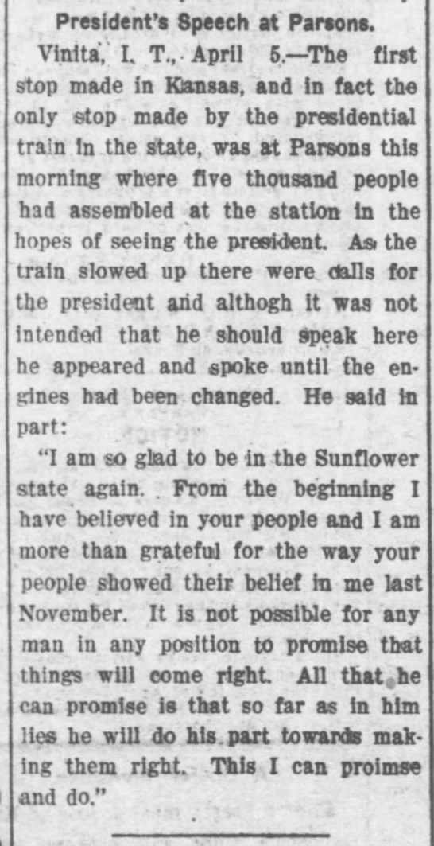
The Parsons Daily Sun
(Parsons, Kansas)
5 Apr 1905, Wed • Page 1

